# Digital Control: Exercise 6b

Xu Fei feixu12@student.hh.se

## Basic theory

1. **Hierarchical control of position and pendulum**

The geometric model of pendulum is shown in figure 1.1.

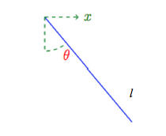

Figure 1.1 Geometric model of pendulum

Here, we will focus on use hierarchical control structure to get a design which pendulum can follow the reference that we choose. First, hierarchical control structure design an inner loop for the position control by the servo, second, it design an outer loop for pendulum stabilization.

1. **Servo position control**

The servo model is an integrator with unit gains for simplicity, i.e.

$$\dot{x}=u$$

Where $x$ is the position and $u$ the input (voltage) to the servo. After zero-order- hold sampling with sampling period $h=1$, the discrete-time model becomes:

$$x\left(k\right)=\frac{q^{-1}}{1-q^{-1}}u(k)$$

Since this system is unstable, it must be stabilized by feedback. Choosing the P-controller

$$u=r-x$$

Then the closed-loop becomes (dead-bead $A_{c}=1$)

$$x\left(k\right)=q^{-1}r\left(k\right)=r(k-1)$$

And the position will follow the reference directly after one sampling period. This completes the design of the inner loop. You may try how it performs so far by opening the Sysquake-file *PendulumMove.sq*. In the animated pendulum window you can click on the reference $r$ (a black ring) and move it horizontally. The pendulum will then follow after one sampling period, causing the large oscillations. The task is to avoid these oscillations while moving the pendulum. This is the objective of the outer loop design and your challenge.

1. **Stabilization while moving the pendulum**

Since the reference to the servo is going to act as input to the outer loop we change notation and call it $v$. The external variable $r$ should then be used as reference for $v$. The inner loop is now:

$x=q^{-1}v$

$$u=(1-q^{-1})v$$

­­

Let the pendulum dynamics (for either down or up situation) be:

$$Ay=Bu$$

Substituting $u$ gives the system of interest:

$$Ay=B(1-q^{-1})v$$

The controller to find for the outer loop is

$$Rv=-Sy+Tr$$

Where $R$ and $S$ are solved from the polynomial equation:

$$AR+B(1-q^{-1})S=A_{c}$$

And $A_{c}$ is chosen for stabilization or damping of the pendulum dynamics. Since

$$v=\frac{AT}{A_{c}}r$$

It follows that the simplest choice for $T$ is to adjust the steady-state gain as:

$$T=\frac{A_{c}}{A}\left(1\right)=R(1)$$

Which makes $v\left(k\right)→r\left(k\right)$, when $k→∞$.

## Control design

Use the zero-order-hold sampled models derived in previous exercise and make controller design as above for the pendulum down and up. Base the design on the sampled models.

1. Down:

Find $R$ and $S$ that gives ${\left\|Sy\right\|}_{∞}<2$ and choose $T=R (1)$.

From exercise 6a, we already get the sample model for ‘down’ is:

$$H\left(q^{-1}\right)=\frac{-0.8034q^{-1}+0.8034q^{-2}}{1-1.0452q^{-1}+0.9048q^{-2}}$$

And from part1 we know:

$$u=(1-q^{-1})v$$

$$Ay=B(1-q^{-1})v$$

So the new sampled model should be:

$$G\left(q^{-1}\right)=\frac{B(1-q^{-1})}{A}=\frac{(-0.8034q^{-1}+0.8034q^{-2})(1-q^{-1})}{1-1.0452q^{-1}+0.9048q^{-2}}$$

$$→G\left(q^{-1}\right)=\frac{(-0.8034q^{-1}+1.6068q^{-2}-0.8034q^{-3})}{1-1.0452q^{-1}+0.9048q^{-2}}$$

So $A=[1,-1.0452, 0.9048,0]$ and $B=[0,-0.8034, 1.6068,-0.8034]$. Try to move all the poles to the positions can give ${\left\|Sy\right\|}_{∞}<2$ in *polp.sq*.

The result is shown in figure 2.1.

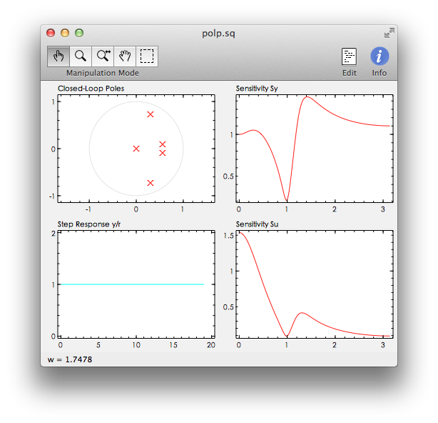

Figure 2.1 Polp figure for ‘down’

Then we can get:

$$R=\left[1,-0.8958,0.1348\right], S=[-0.2699,-9.736e-2,-1.8717e-9]$$

Then we can get $T$ is:

$$T=\frac{A_{c}}{A}\left(1\right)=R\left(1\right)=1-0.8958+0.1348=0.239$$

1. Up:

Find $R$ and $S$ that gives ${\left\|Sy\right\|}_{∞}<4$. Then in order to speed up the reference response, cancel the slowest pole in $A_{c}$ by including it in $T$. Thus, if $λ_{s}$ is the dominating (slowest) pole choose $T=R (1)(1-λ_{s}q^{-1})/(1-λ_{s})$.

From exercise 6a, we already get the sample model ‘up’ is:

$$H\left(q^{-1}\right)=\frac{1.1150q^{-1}-1.1150q^{-2}}{1-2.9172q^{-1}+0.9050q^{-2}}$$

And from part1 we know:

$$u=(1-q^{-1})v$$

$$Ay=B(1-q^{-1})v$$

So the new sampled model should be:

$$G\left(q^{-1}\right)=\frac{B(1-q^{-1})}{A}=\frac{(1.1150q^{-1}-1.1150q^{-2})(1-q^{-1})}{1-2.9172q^{-1}+0.9050q^{-2}}$$

$$→G\left(q^{-1}\right)=\frac{(1.1150q^{-1}-2.23{00q}^{-2}+1.1150q^{-3})}{1-2.9172q^{-1}+0.9050q^{-2}}$$

So $A=[1,-2.9172, 0.9050,0]$ and $B=[0,1.1150, -2.2300, 1.1150]$. Try to move all the poles to the positions can give ${\left\|Sy\right\|}_{∞}<4$ in *polp.sq*.

The result is shown in figure 2.2.

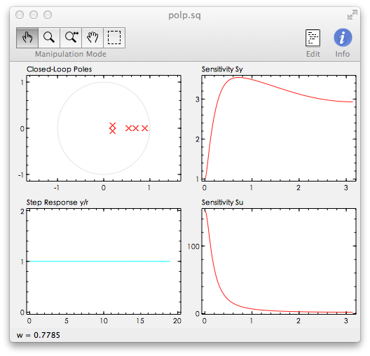

Figure 2.2 Polp figure for ‘up’

Then we can get:

$$R=\left[1,-2.14967,1.1398\right], S=[2.28927,-0.77906,-1.2375e-2]$$

Then we can get $T$ is:

$$T=R\left(1\right)(1-λ_{s}q^{-1})/(1-λ_{s})$$

And we can easily get the slowest pole is the one closest to the unit circle,

$$A_{c}=AR+BS$$

$${→A}_{c}=1-2.5143q^{-1}+2.3421q^{-2}-0.9945q^{-3}+0.1905q^{-4}-0.013799q^{-5}$$

$${→A}_{c}=\left(1-{0.8904q}^{-1}\right)\left(1-0.6966q^{-1}\right)\left(1-{0.5407q}^{-1}\right)(1-{(0.1934 +0.061375i)q}^{-1})(1-{(0.1934 -0.061375i)q}^{-1})$$

Obviously, we can found $λ_{0}=0.8904$ is the one closest to the unit circle. So we can get:

$$T=R\left(1\right)(1-0.8904q^{-1})/(1-0.8904)$$

$$→T=(1-2.1348+1.12755)(1-0.8904q^{-1})/(1-0.8904)$$

$$→T=-0.06615+0.0589q^{-1}$$

## Implementation and verification

From part1, we know:

$$Rv=-Sy+Tr$$

$$→v=\frac{Tr-Sy}{R}$$

So, the structure for this exercise should be:

$1-q^{-1}$

*T*

*v*

*y*

*B⁄A*

*r*

*1⁄R*

Figure 3.1 Structure of Hierarchical control

1. Down.

From part2a), we get:

$$R=\left[1,-0.8958,0.1348\right], S=[-0.2699,-9.736e-2,-1.8717e-9]$$

$$T=\frac{A_{c}}{A}\left(1\right)=R\left(1\right)=1-0.8958+0.1348=0.239$$

$$v=\frac{Tr-Sy}{R}=\frac{0.239r-(-0.2699-(9.736e-2)q^{-1}-(1.8717e-9)q^{-2})y}{1-0.8958q^{-1}+0.1348q^{-2}}$$

$$→v=0.239r\left(k\right)+0.2699y\left(k\right)+\left(9.736e-2\right)y\left(k-1\right)+$$

$$\left(1.8717e-9\right)y\left(k-2\right)+0.8958v\left(k-1\right)-0.1348v(k-2)$$

The signal figure is shown is figure 3.2.

(The Sysquake file is *PendulumDamp_down.sq* in the attachments).

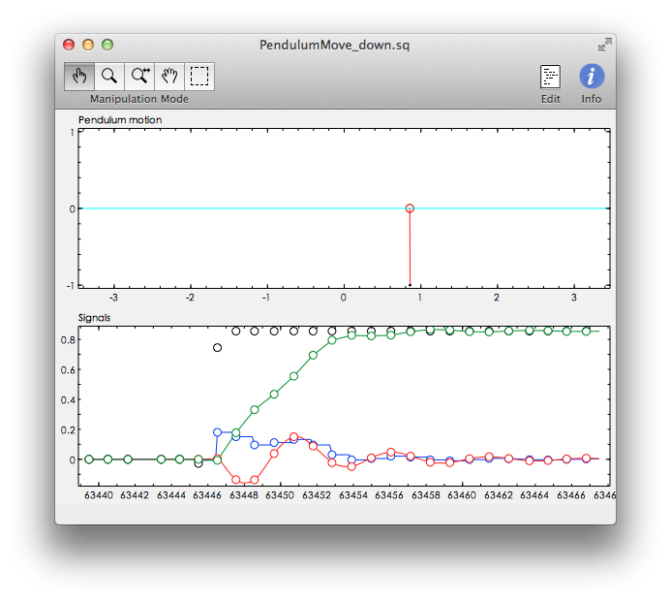

Figure 3.2 Pendulum model for ‘down’

1. Up.

From part2a), we get:

$$R=\left[1,-2.14967,1.1398\right], S=[2.28927,-0.77906,-1.2375e-2]$$

$$T=R\left(1\right)(1-λ_{s}q^{-1})/(1-λ_{s})=-0.06615+0.0589q^{-1}$$

$$v=\frac{Tr-Sy}{R}=\frac{(-0.06615+0.0589q^{-1})r-(2.28927-0.77906q^{-1}-0.012375q^{-2})y}{1-2.14967q^{-1}+1.1398q^{-2}}$$

$$→v=-0.06615r\left(k\right)+0.0589r\left(k-1\right)-2.28927y\left(k\right)+0.77906y\left(k-1\right)+0.012375y\left(k-2\right)+2.14967v\left(k-1\right)-1.1398v(k-2)$$

The signal figure is shown is figure 3.3.

(The Sysquake file is *PendulumDamp_up.sq* in the attachments).

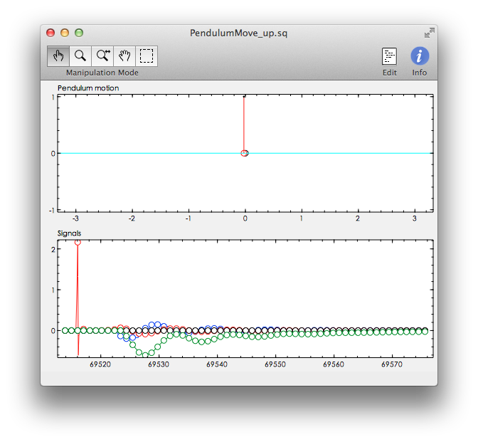

Figure 3.3 Pendulum model for ‘up’

From the result, we can see that both the ‘Down’ controller and the ‘Up’ controller are work well. They don’t take very long time for feeding back to the balance state.